INTRODUCTION
About this Document:
This document is intended for computer laboratory users, offering insights into the Attendance Management System (AMS). It provides essential information about the system's purpose, features, and instructions for effective utilization.
System Overview
The Attendance Management System (AMS). is an advanced software solution designed to automate and optimize student attendance monitoring in computer laboratories. This comprehensive system offers administrators a seamless tool for efficient attendance management, with real-time tracking and a user-friendly interface. AMS revolutionizes attendance management by enhancing efficiency, accuracy, and transparency, benefiting both administrators and students. The system replaces outdated manual tracking methods, reducing the risk of data loss, and ensuring secure and centralized digital storage of attendance records. By embracing AMS, educational institutions can foster a well-organized, accountable, and technologically advanced environment within computer laboratories. Additionally, AMS extends its functionality to address the security and accountability of devices and properties within the labs, providing a holistic solution for managing assets and incidents effectively.

SYSTEM REQUIREMENTS
Below are the system requirements for the development of the Computer Laboratory Attendance Tracking Management System:
Hardware Requirements

- Personal Computer (PC)
  - Capable of running the selected development tools and servers with sufficient processing power.
- Laptops
  - Compatible laptops to support the development environment and testing of the system.
- Laptop Specifications
  - Operating System : Microsoft Windows 10 Pro
  - Manufacturer: Dell Inc.
  - Processor: Intel(R) Core(TM) i3-4030U CPU @ 1.90GHz, 2 Cores, 4 Logical Processors
  - RAM: 8.00 GB
Software Requirements:
- Operating System:
  - Microsoft Windows 10 Pro
- Integrated Development Environment (IDE):
  - Apache Netbeans IDE Version 20
- Java Development Kit (JDK):
  - Version 21
- Server
  - XAMPP Server Version 3.3.0
- Includes Apache, MySQL, PHP, and Perl for local development and testing.
- Database Connectivity
  - MySQL Connector/J Version 8.2.0
    - Facilitates communication between the Java application and the MySQL database.
- Development Environment:
  - Internet Connection (Optional)
    - Although the system can be developed and tested locally, an internet connection might be required for downloading updates or additional libraries during development.
- Additional Notes:
  - Development Approach
    - Local Offline Development (LOAD) - designed to operate without continuous internet connectivity.
  - Compatibility and Version Control:
    - Ensure that all components (IDE, JDK, XAMPP, MySQL Connector) are compatible with each other. Use the specified versions to avoid compatibility issues.
  - Security Considerations
    - Implement security measures for the local development environment to protect sensitive data.
These system requirements, along with the specified laptop specifications, provide a comprehensive foundation for creating a robust Computer Laboratory Attendance Tracking Management System. Ensure that the specified hardware and software components are installed and configured correctly for effective development.

USER INTERFACE GUIDELINES
This document outlines essential user interface design guidelines for the Attendance Management System (AMS). The purpose is to provide clear guidance to system operators on the proper usage and navigation through the system. By following these guidelines, users will be able to interact seamlessly with AMS, ensuring an efficient and intuitive experience.
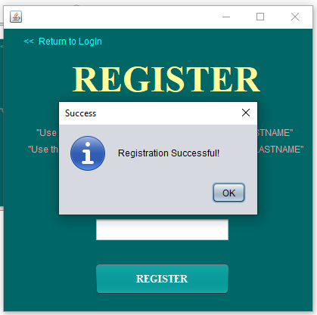
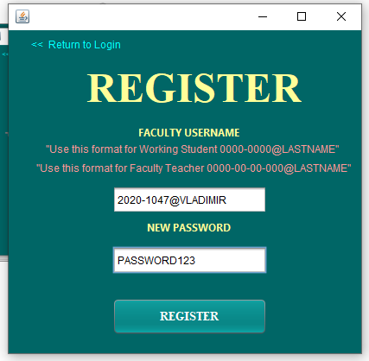

2
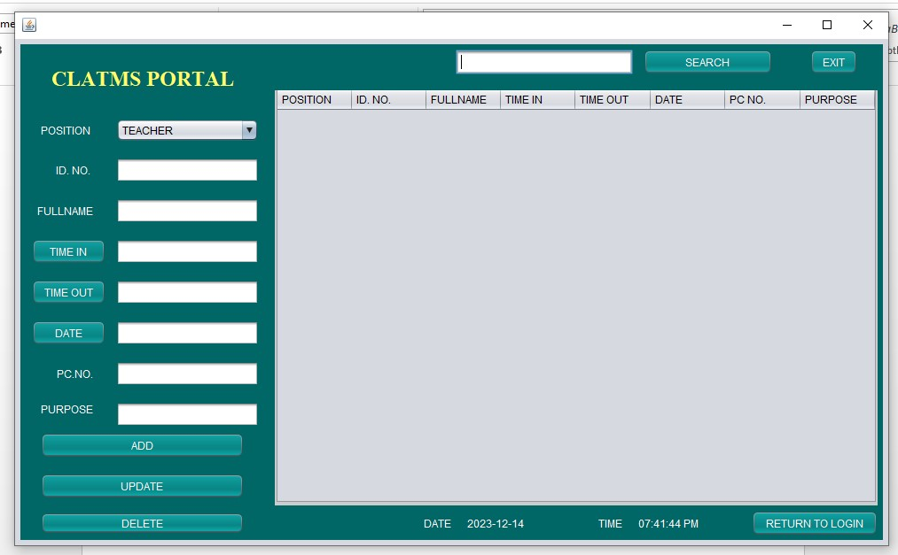
1

REGISTER PAGE
Faculty Admin Registration:
- The faculty admin, being in charge, initiates the registration process.
- Navigate to the registration page within AMS.
Input Faculty Details:
- Enter the unique Faculty ID No. for identification purposes follow also the format "Use this format for Working Student 0000-0000@LASTNAME"
"Use this format for Faculty Teacher 0000-00-00-000@LASTNAME"
(e.g., "2020-1047@VLADIMIR").
- Set a secure password for the account (e.g., "PASSWORD123").
Message after successful register:
- Message will appear “Registration Successful!” after press “OK” button.
Submission & Return to Login Page:
- After inputting the required details, upon pressing "RETURN," the faculty admin is redirected to the AMS login page

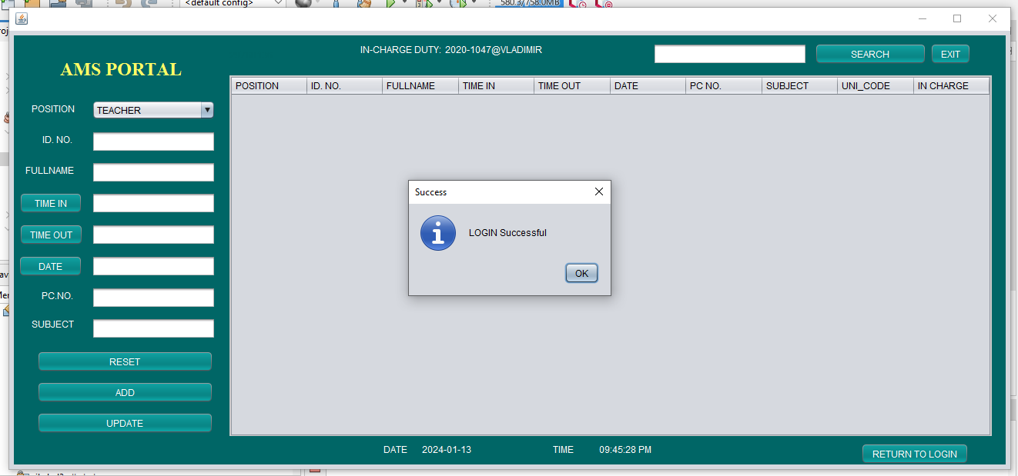
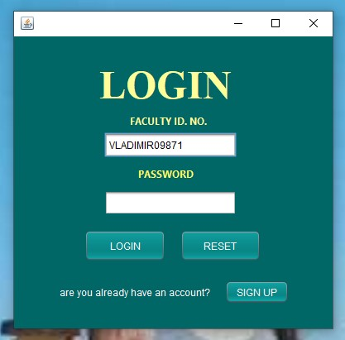
LOGIN PAGE

2
2
2
1

- Access the AMS login page.
- Use the registered Faculty ID No. and password to log in.
Successful Login:
- Upon successful login, a message will appear confirming the login.
Message after successful logging in:
Message:
- "Login Successful!
- Click “OK” to close the message
CLATMS PORTAL PAGE
FEATURES (“ADD”)
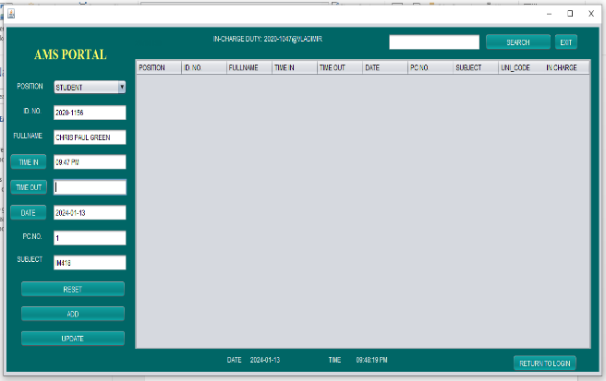
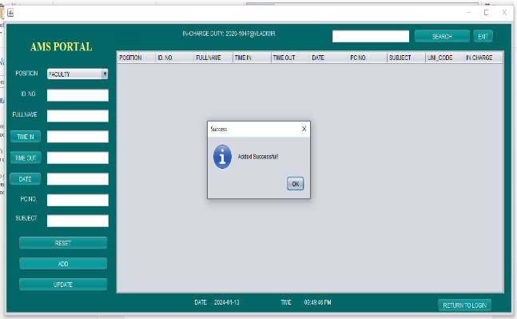

3

1
2

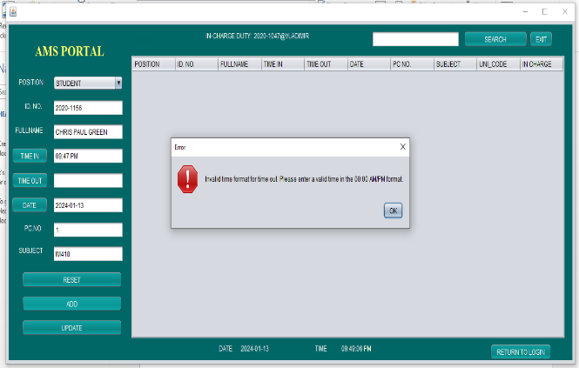
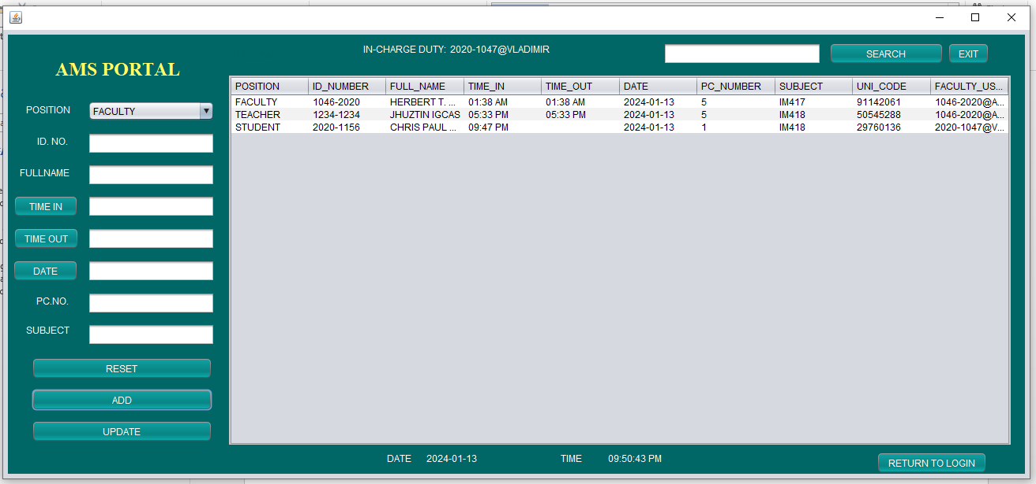

2
4

Navigate to Portal:
>Log in to AMS using your Faculty ID No. and password.
>Once logged in, you will be directed to the AMS portal page.
Information Input:
>Locate the section for inputting information (e.g., student details, attendance data).
Fill Out Information:
>Input the required information into the designated fields (e.g., student name, ID, date of attendance).
Add to Table:
>After filling out the information, click the "Add" button to submit and include the data in the corresponding table.
Error Message:
>“Invalid time format. Please enter a valid time out the 00:00 AM/PM format.” But don’t worry it will proceed the Time out field is waiting for UPDATE button in order all information will fill out information.
Message after successful logging in:
>A confirmation message will appear acknowledging the successful addition of information.
Message:
>"Information Added Successfully!"
Continue Inputting Data:
>If you have more data to input, repeat the process by filling out information and clicking "Add."
Table Display:
>The added information will be dynamically displayed in the table on the portal page.
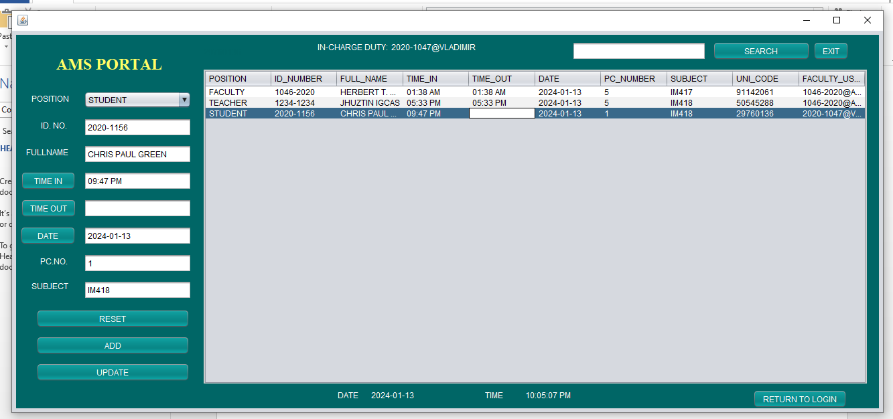
FEATURES (“UPDATE”)

1

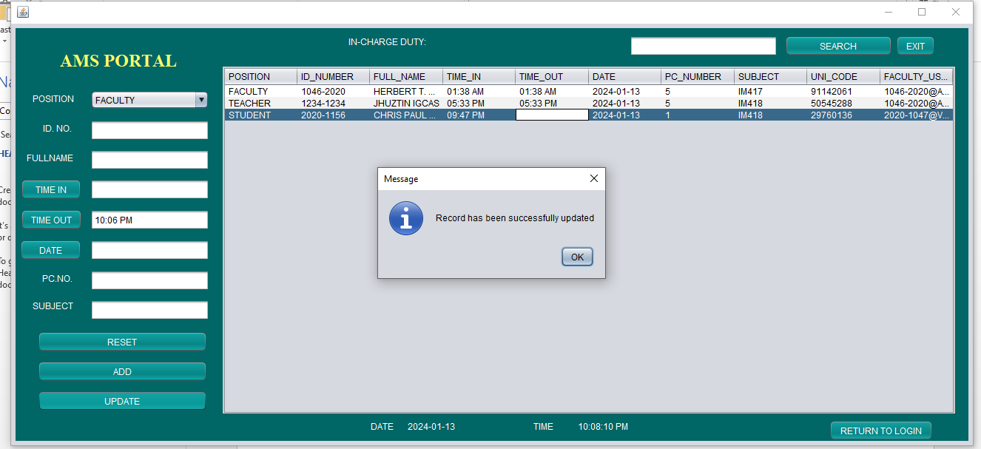

2

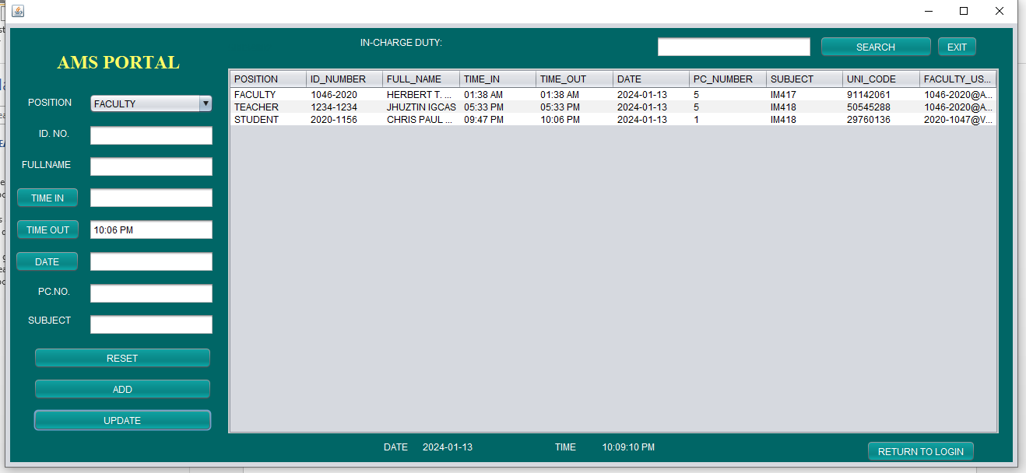

3

Select Record to Update:
>Locate the record or information you want to modify in the displayed table.
Modify Information:
>Update the necessary information in the designated fields.
Click on Update:
>Select the "Update" option associated with the record you wish to modify.
Message after Updating successful logging in:
Message:
>"Record has been successfully updated!"
Continue Editing:
>If you have more records to update, repeat the process by selecting another record and making the necessary modifications.
Table Display:
>The updated information will be reflected in real-time on the portal's displayed table.

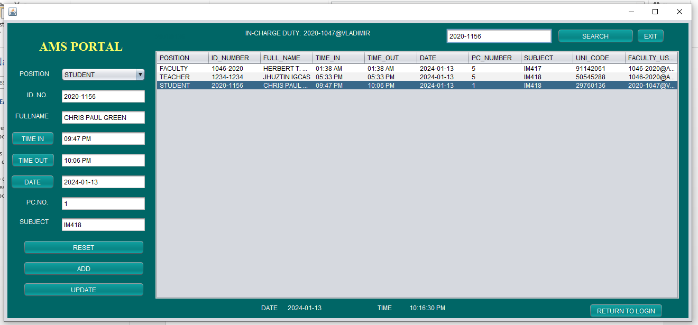
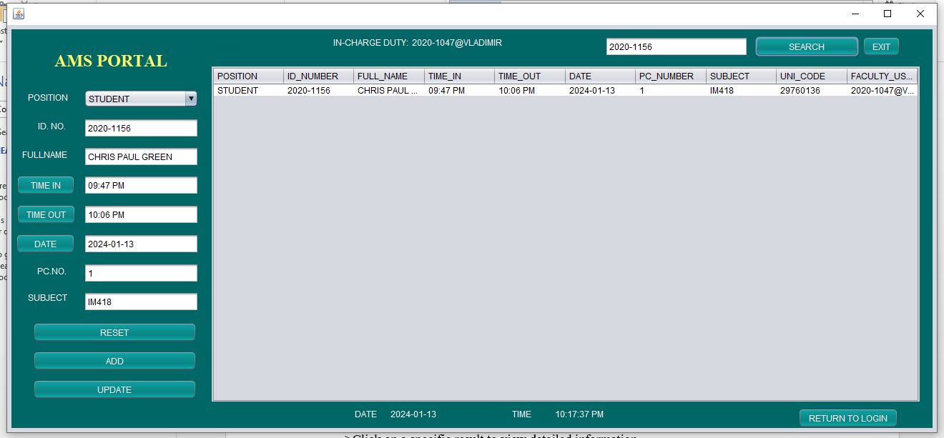
FEATURES (SEARCH)
Navigate to Search Page:
>Log in to AMS using your Faculty ID No. and password.
`Once logged in, find and access the "Search" page within the portal.
Enter Search Criteria:
>Identify the search criteria, such as a student's name, ID, or date of attendance.
Input Search Query:
>Enter the relevant information into the search field.
Initiate Search:
>Click the "Search" or "Find" button to initiate the search.
View Search Results:
>The system will display the search results based on the provided criteria.
Detailed Information:
>Click on a specific result to view detailed information.
Refine Search:
>If needed, refine the search by adjusting the search criteria and repeating the process.
Message:
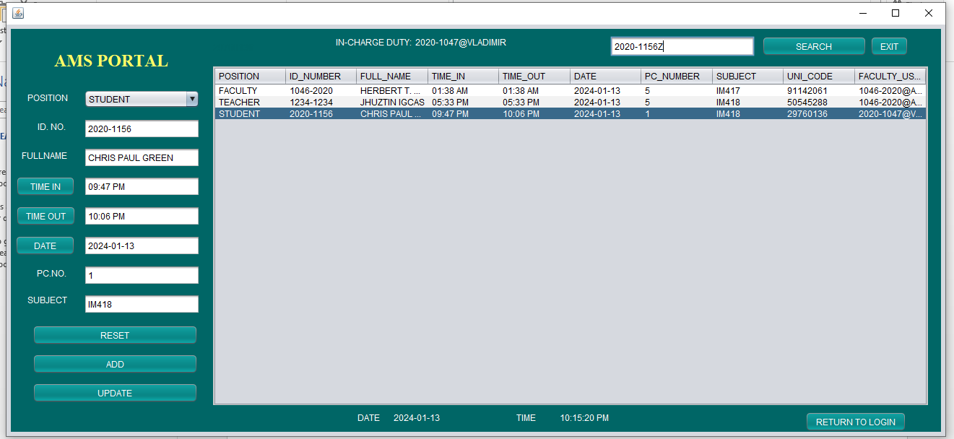
>”No record found” if you entered wrong Id_number

3

2

1

FEATURES (“RESET & RETURN TO LOGIN, EXIT RESET”)
RESET:
>it will erase or I mean it will empty if you click reset button to empty the text field and you may start another field to fill out.
After Adding, Updating, or Deleting:
>Regardless of whether you added, updated, or deleted records, a common practice is to automatically redirect users to the login page upon completion of these actions.
Automatic Redirect:
>Alternatively, implement an automatic redirect mechanism that redirects users to the login page a few seconds after the completion of any action.
EXIT and Manual Return:
>If there isn't an automatic redirect, users can manually click on the "EXIT" option after completing their actions, and they will be directed to the login page.
EXIT Button:
>Always provide a visible "EXIT" button on each page, allowing users to log out at any time, which will naturally return them to the login page.

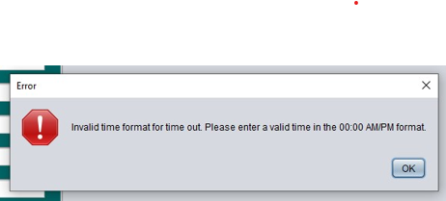
Handling errors, it will occurred if the information you input is invalid:

Just click time in button and fill out other in ensure that you fill out the information.
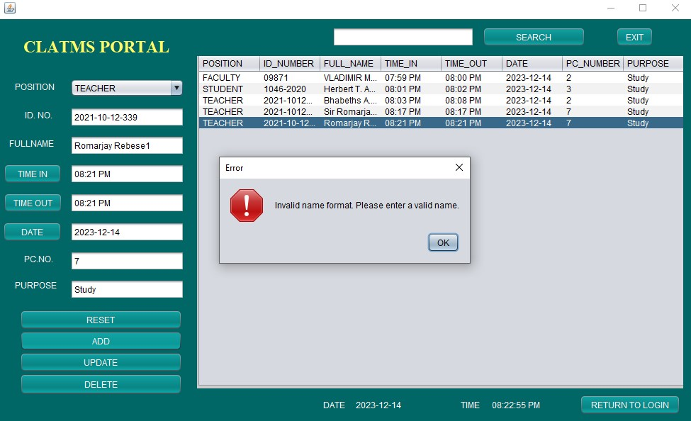

Just fill out valid name ensure that there is no numbers in the field.
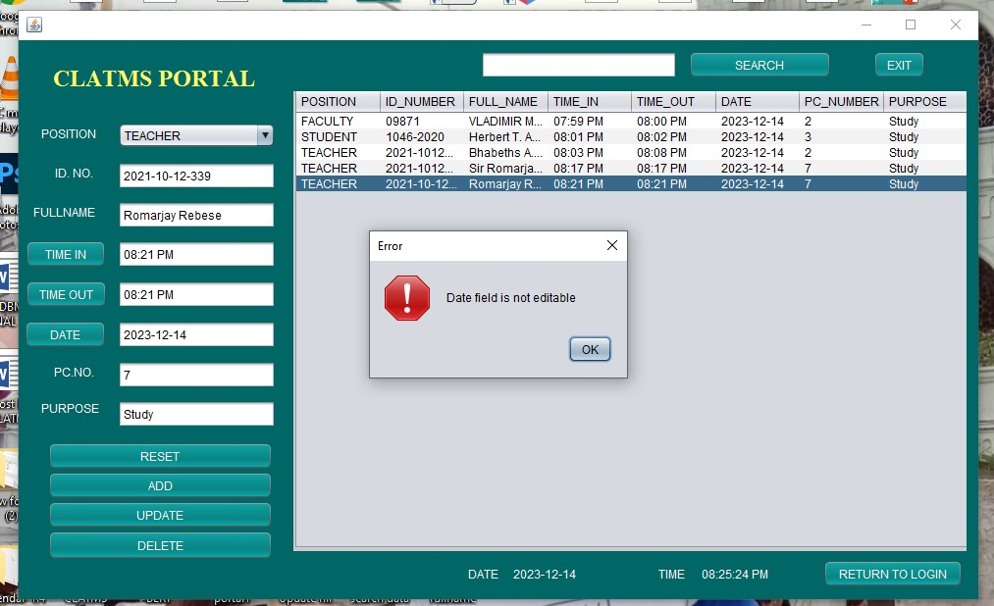

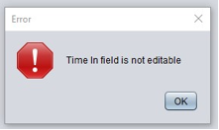
You cannot edit the date only time out and pc number will be edited
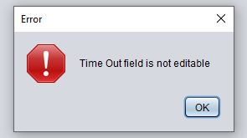

If you try change the time in by typing in the field it will not work. Just click the time button and it will change and click update if you want to update or change the tie out

If you try change the time in by typing in the field it will not work, just press the button and only time out will be edited
DATABASE
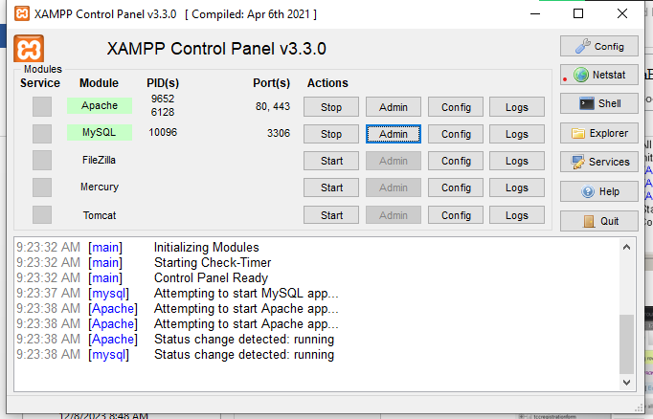

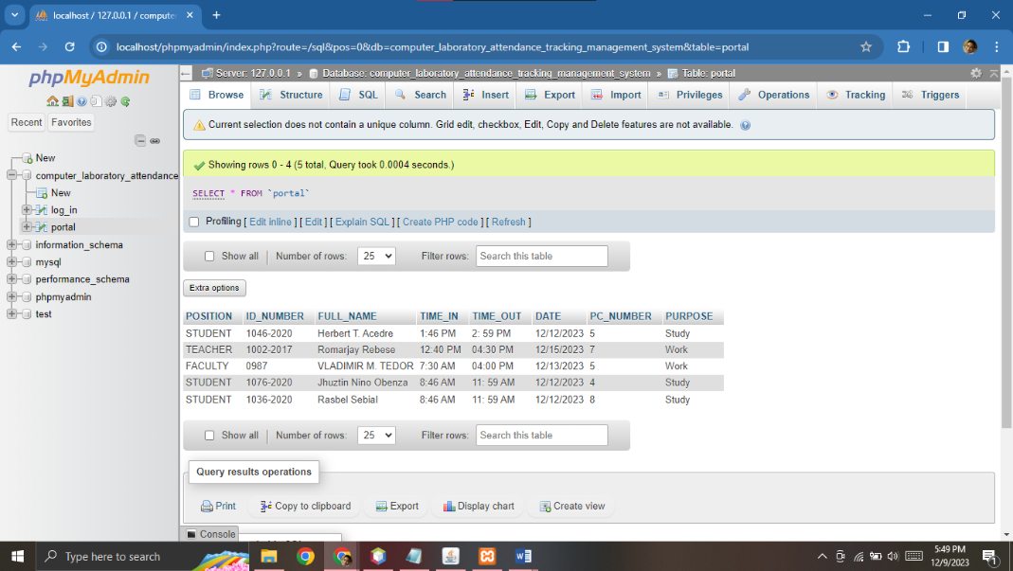

After initiating the XAMPP Panel, you have the capability to review, print, and modify the data of students, teachers, and faculty administrators within this interface.

